RYAN SPORTS CLUB  
USER GUIDE

|  |  |  |
| --- | --- | --- |
| **Supervisor :** | **Zaman.** | |
| **Batch :** | **2209E01.** | |
| **Group :** | **Ryan sports club** | |
| **Serial No.** | **Enrollment No.** | **Student Names.** |
| **1.** | **22894** | **Fareed Munawar** |
| **2.** | **77732** | **Ali Rizwi** |
| **3.** | **424432** | **Adeel** |
| **4.** | **787432** | **Noman khan** |

***USER GUIDE***

***“RYAN-SPORTS-CLUB” This website is basically based on sports as you can see in the Title name. If you are passionate about the sports, so this website is made for you.***

1. ***Top Layout:***

*This is the top of the page.*

* *User can login or signup by clicking on logo.*
* *User can know about the Indoor and Outdoor sports by clicking on about.*
* *Users can get check the upcoming events by clicking on events.*
* *Users can choose their favorite sports by hovering on indoor-sports or outdoor-sports.*



1. ***Home Page:***

*This is Home page.*

* *User can login or signup by clicking on Join now Button.*
* *Created the home page attractive that user can Like/Love.*

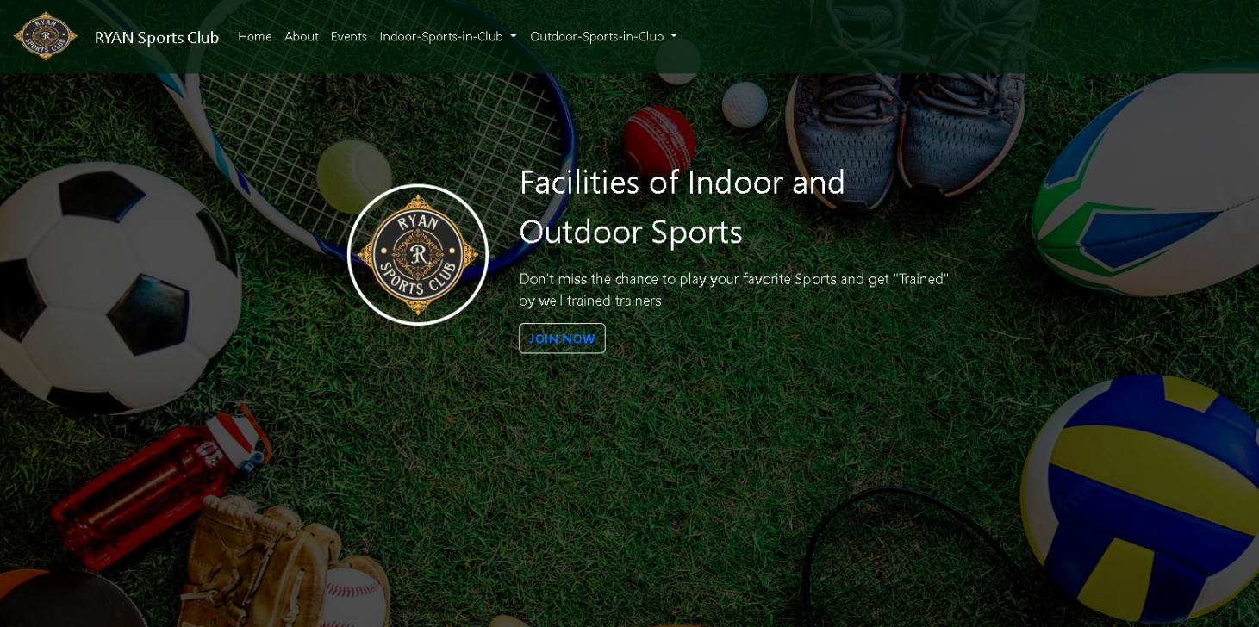

1. ***About Page:***

*This is about page.*

* *User can get Info about indoor and outdoor games.*
* *Added multiple images of outdoor and indoor games.*

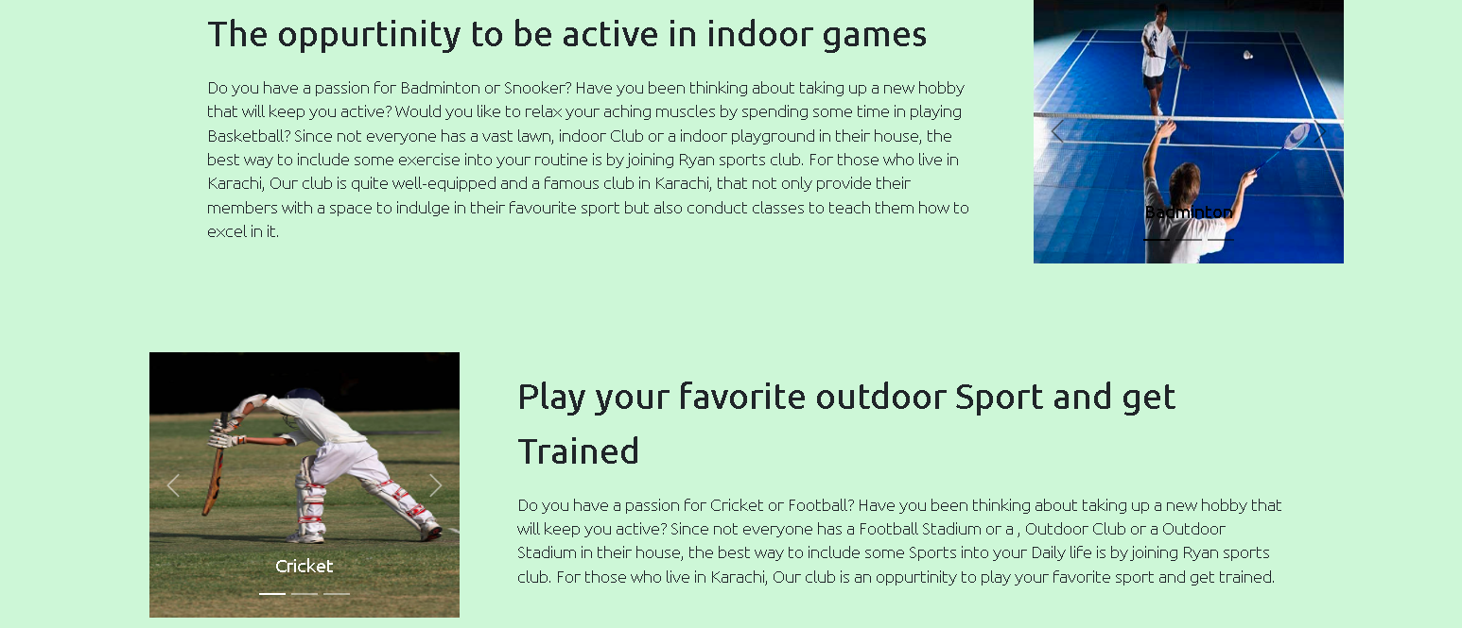

1. ***Events Page Top Layout:***

*This is events page top layout.*

* *User can get Info about Upcoming events and can join by clicking on join now.*
* *Added an attracted background image.*



1. ***Events Page Bottom Layout:***

*This is events page bottom layout.*

* *User can get Info about Upcoming events.*
* *Added carousel/slider of multiple upcoming events images.*

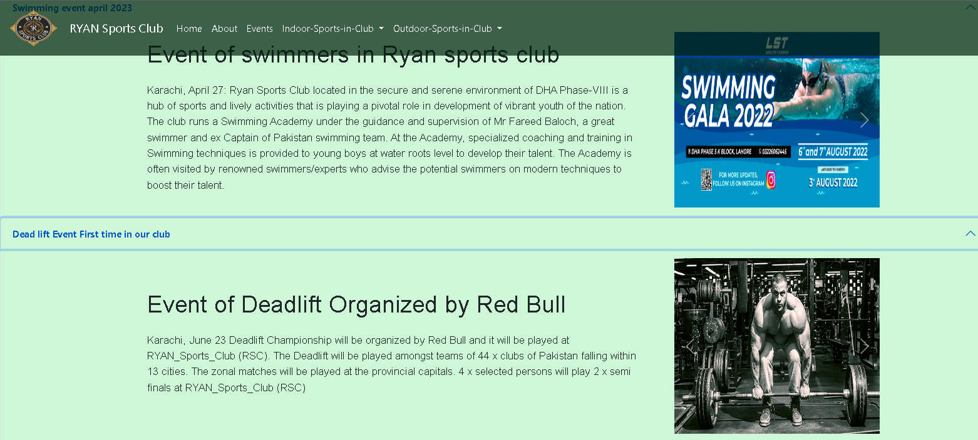

1. ***Indoor and Outdoor sports Layout:***

*This is Indoor and outdoor sports layout.*

* *User can see the indoor and outdoor sports as Images can join by clicking on join now.*
* *User can choose their favorite sports by clicking on Indoor/outdoor sports dropdown.*
* *Added attracted images.*

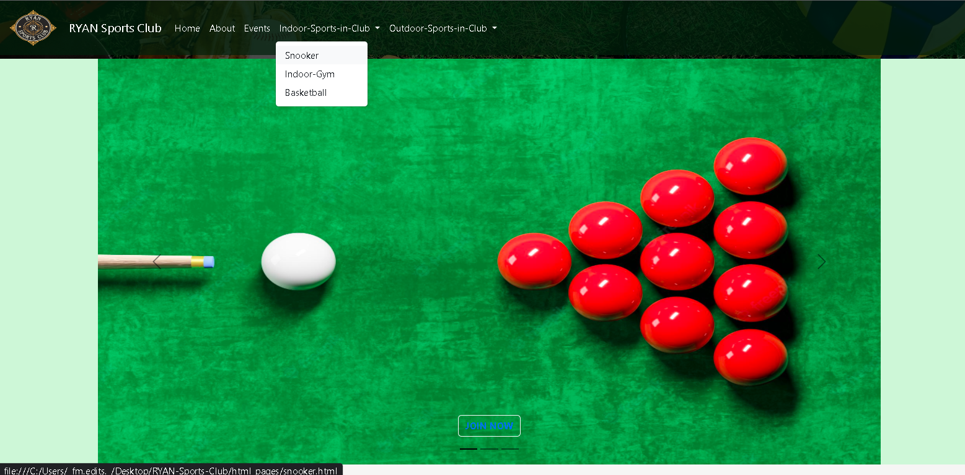

1. ***Contact us form:***

*This is Contact us form.*

* *User can contact us by adding there information like name, phone, Gmail, and there comments.*



1. ***Signup page:***

*This is Signup page.*

* *User can Sign up just by adding there information like name, Gmail, Gender, Age, and a password.*
* *User can also join our club and get more details after the Signup.*

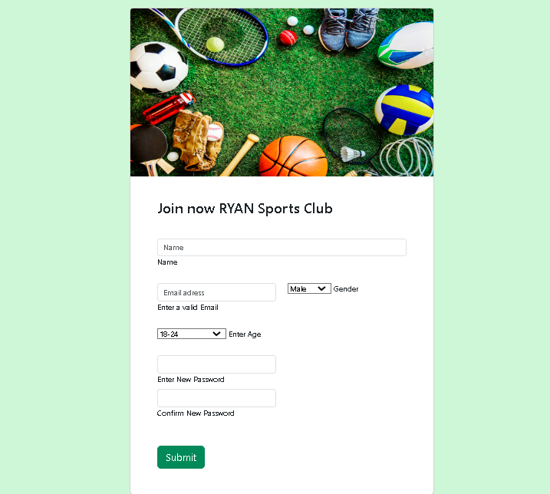

1. ***Footer:***

*This is Footer.*

* *User can check our Services of indoor games, outdoor games and sports.*
* *User can get information about our Club, Trainers, and Legacy.*
* *And in the last user can check out other branches of Ryan sports club*



Thanks for Reading

***USER GUIDE***